Doctor Appointment System
Mobile Application Development Project-Complex Engineering Problem
By
Ms. Mariam Memon



Assignment submitted to MUET for the degree of
Bachelor of Engineering
In
Software Engineering

Assignment submitted by
22SW042
22SW160

November 2025
- Real World Problem Identification
- Many small businesses, clinics, consultants, and freelance professionals need a cross-platform way to let clients book, view, and manage appointments.
- Problems addressed: fragmented scheduling across phone/email, double-booking, inability to quickly see availability, lack of reminders, and no unified mobile + web interface for both clients and providers.
- Problem Statement
- Provide a cross-platform appointment scheduling application that enables users to create/manage availability, let clients book time slots, handle conflicts, send reminders, and store appointment data reliably and securely across devices.
- Stakeholders
- End users / clients (book appointments)
- Service providers / admins (manage availability, confirm/cancel appointments)
- Business owners / managers (view reports, staff schedules)
- Developers / maintainers (extend and maintain the app)
- Platform providers (Firebase or any backend provider used)
- Regulators & privacy officers (if dealing with personal/health data)
- Proposed Solution — High-Level Architecture
- Flutter front-end delivering mobile (iOS/Android), web, and desktop (macOS, Windows, Linux) clients from a single codebase (project structure indicates multi-platform Flutter).
- Backend-as-a-Service (Firebase) for authentication, database, cloud functions, and push notifications (presence of firebase.json suggests Firebase integration).
- Local persistence layer (small local DB or key-value store) for offline support and fast UI responsiveness.
- Calendar and notification integration on device for reminders.
- Optional REST API façade / cloud functions for advanced business logic and integrations (email, SMS, third-party calendars).
- Overall Architecture (logical components)
- Presentation layer: Flutter UI widgets, responsive layouts for different screen sizes.
- State management layer: central app state for auth, bookings, availability, user profile, and UI state.
- Data layer:
  - Remote DB: Cloud-hosted (Firestore or Realtime DB) to persist users, providers, appointments, notifications, and logs.
  - Local cache: Hive / sqflite or SharedPreferences for offline mode and caching.
- Integration services:
  - Authentication: email/password, social sign-in, or phone auth via Firebase Auth.
  - Push notifications: Firebase Cloud Messaging (FCM) for mobile/web notifications.
  - Background jobs: cloud functions or scheduled tasks for reminders, cleanup, and reports.
- Security layer: rules on backend (Firestore Security Rules), TLS, hashed or tokenized sensitive data storage.
- Responsive User Interfaces
- The lib/ directory and presence of web/ indicate a single Flutter codebase targeting multiple form factors. Recommendations:
  - Use adaptive layouts (LayoutBuilder, MediaQuery) to switch between single-column mobile and multi-column tablet/desktop views.
  - Implement reusable components: appointment card, calendar view, availability editor, booking flow steps.
  - Ensure touch targets, spacing and large-font accessibility for mobile; keyboard & pointer support plus hover for desktop/web.
  - Include light/dark themes and ensure contrast ratios for accessibility.

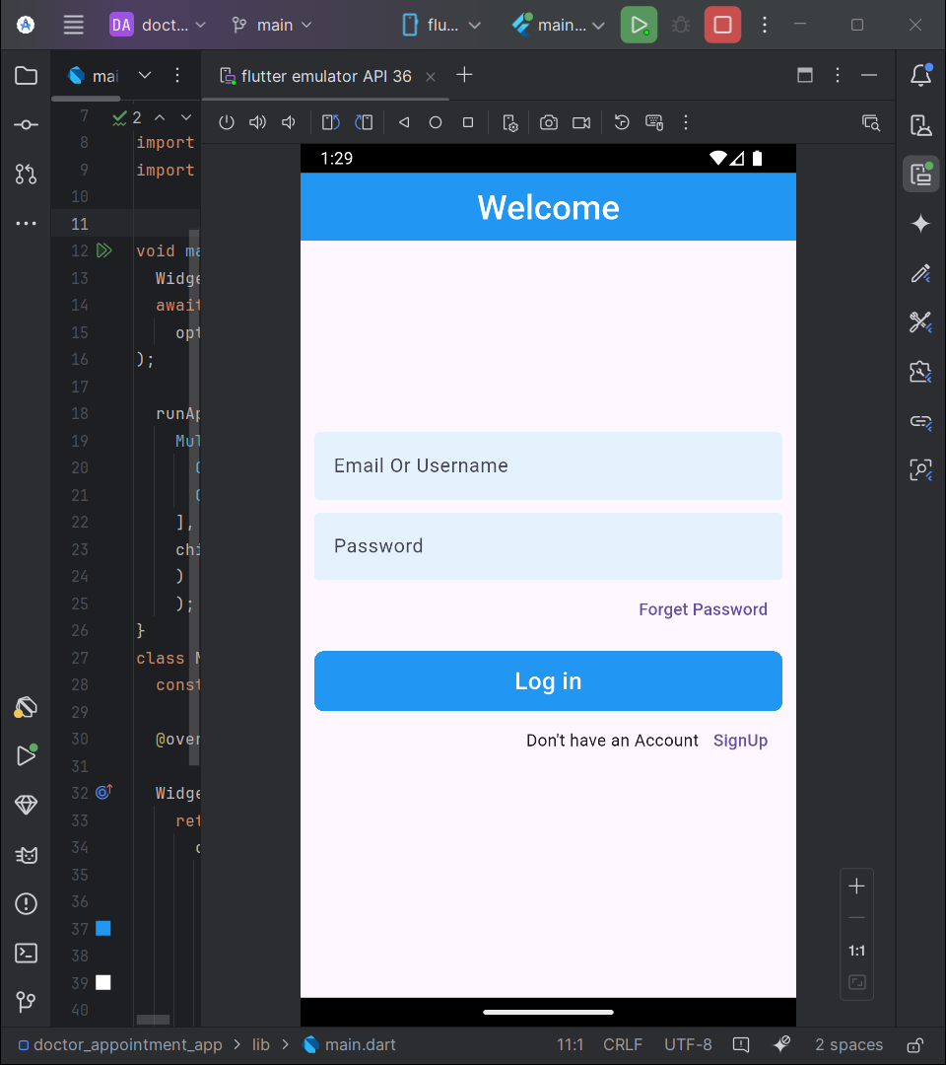
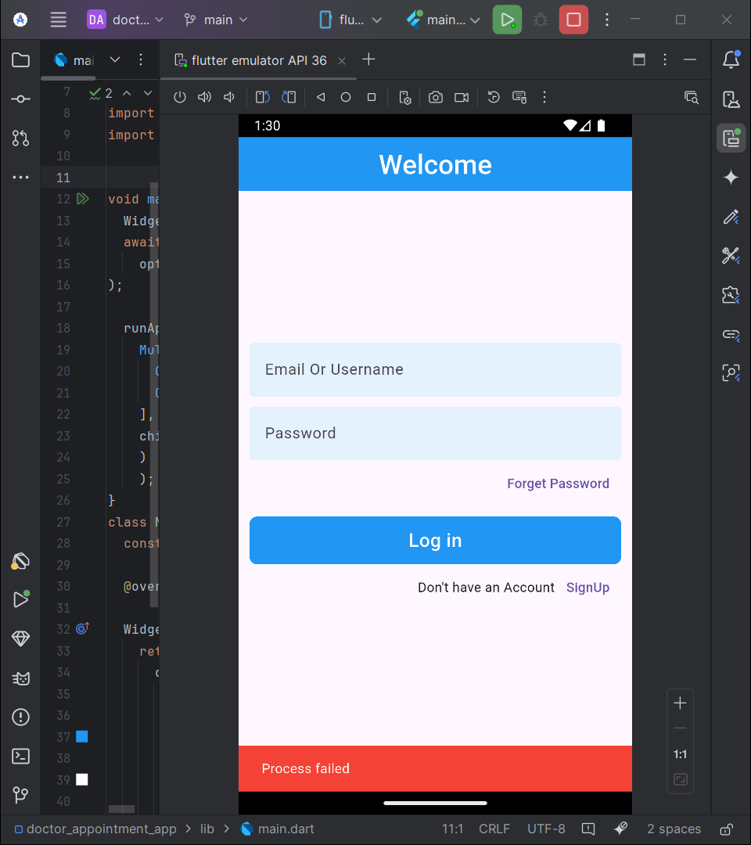
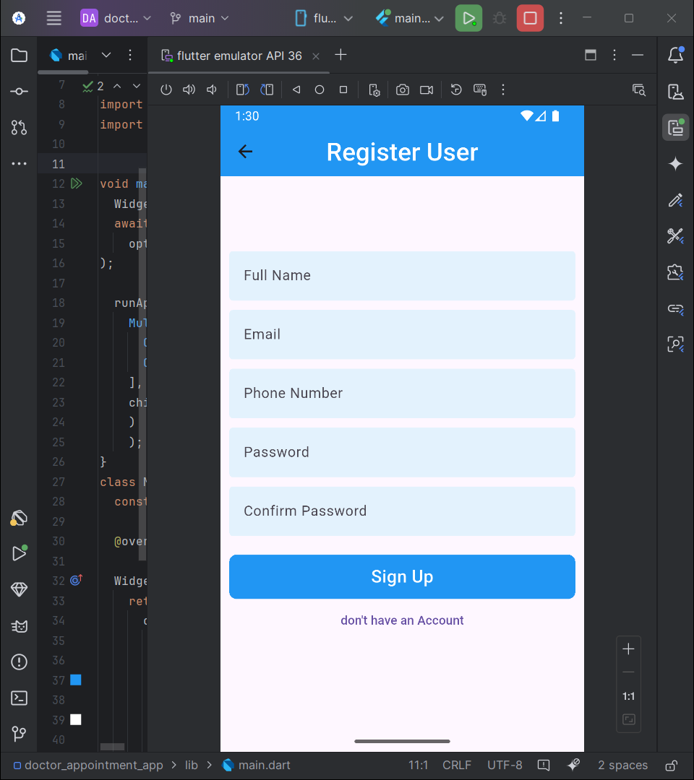

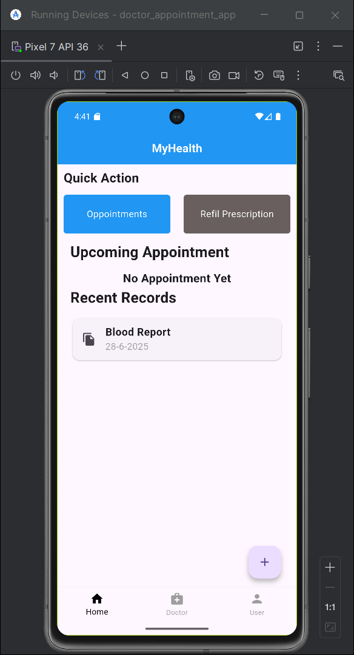
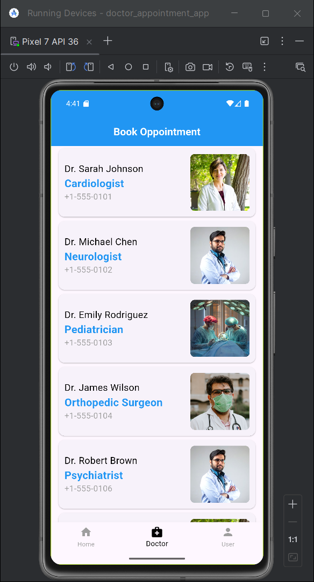
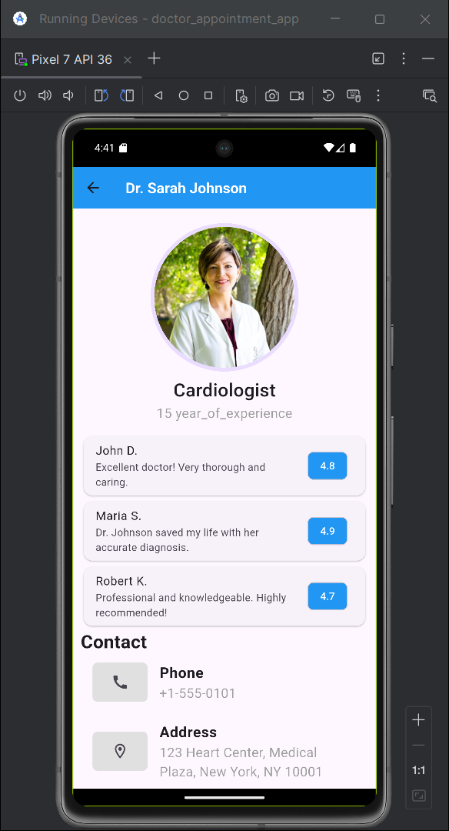
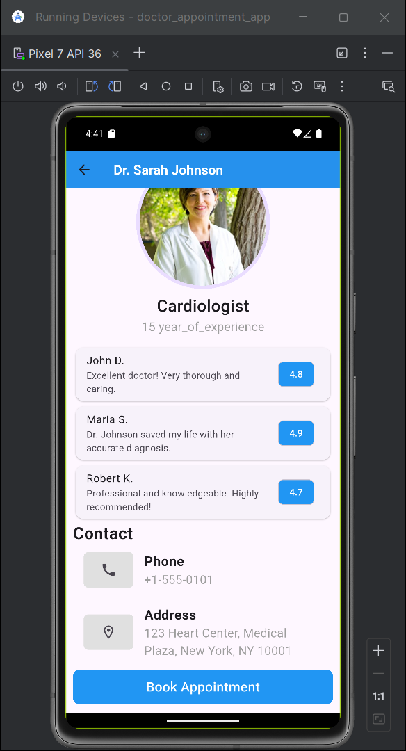
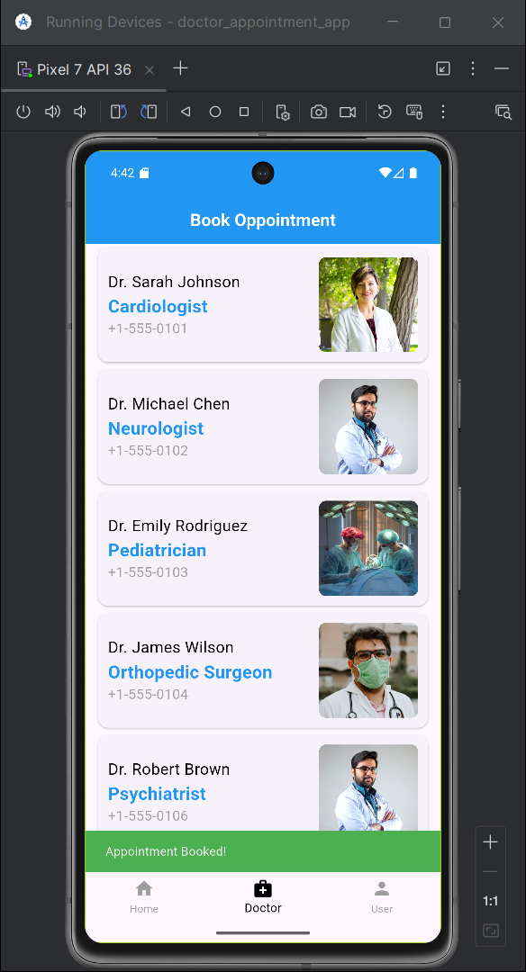
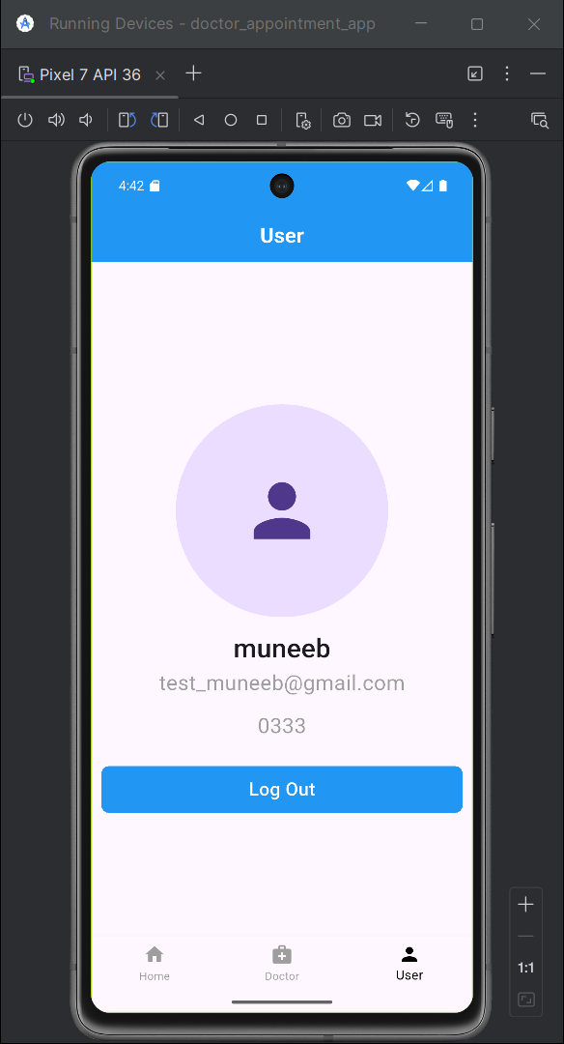
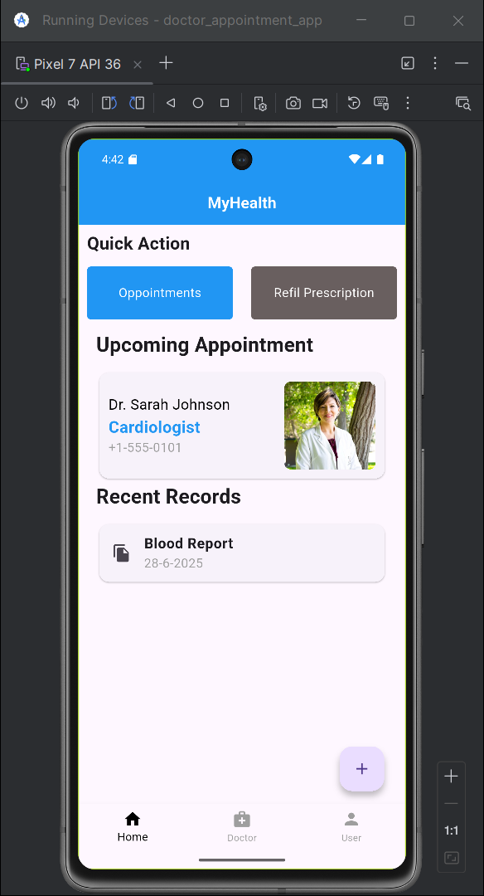
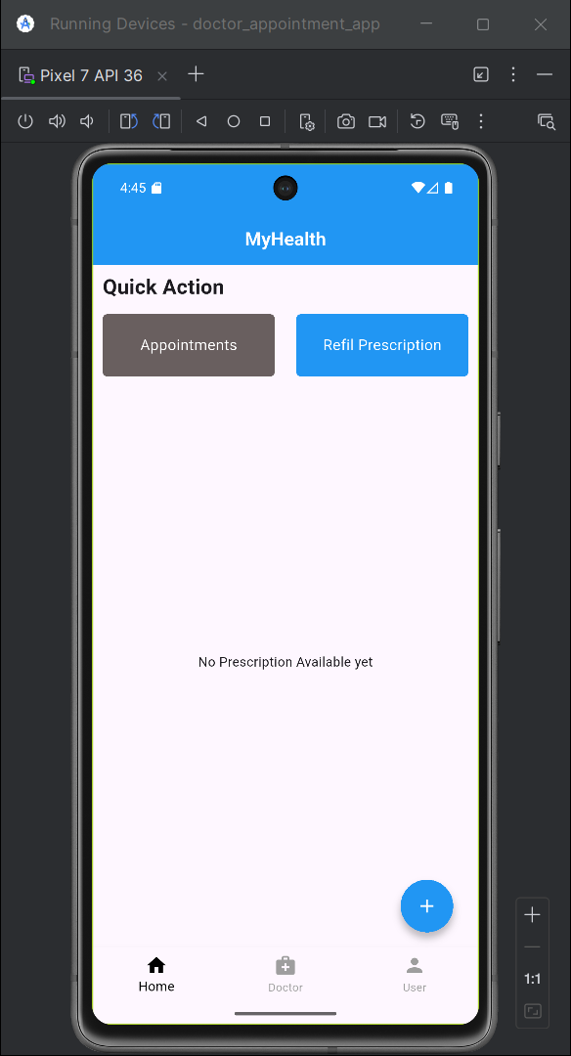
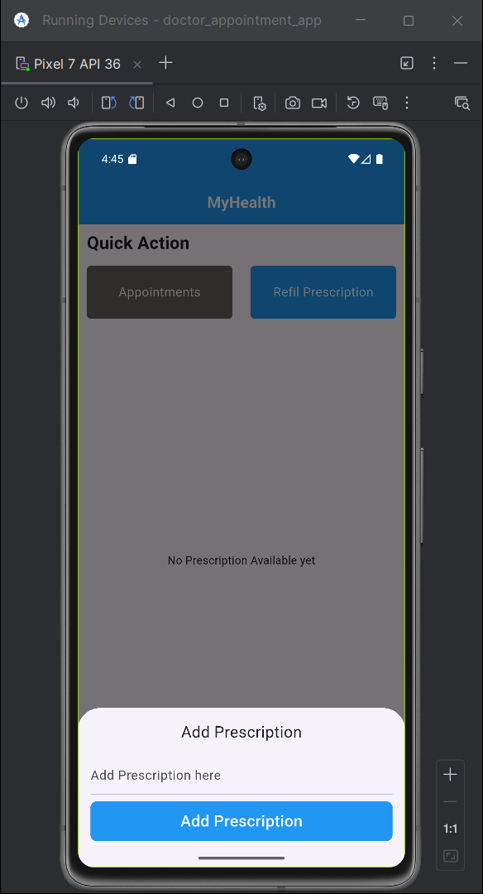
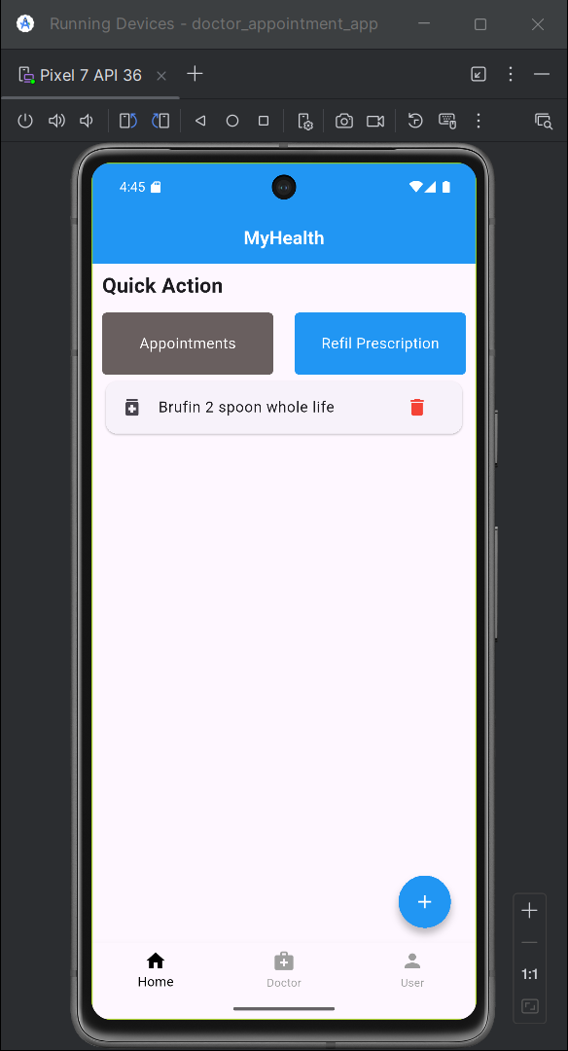
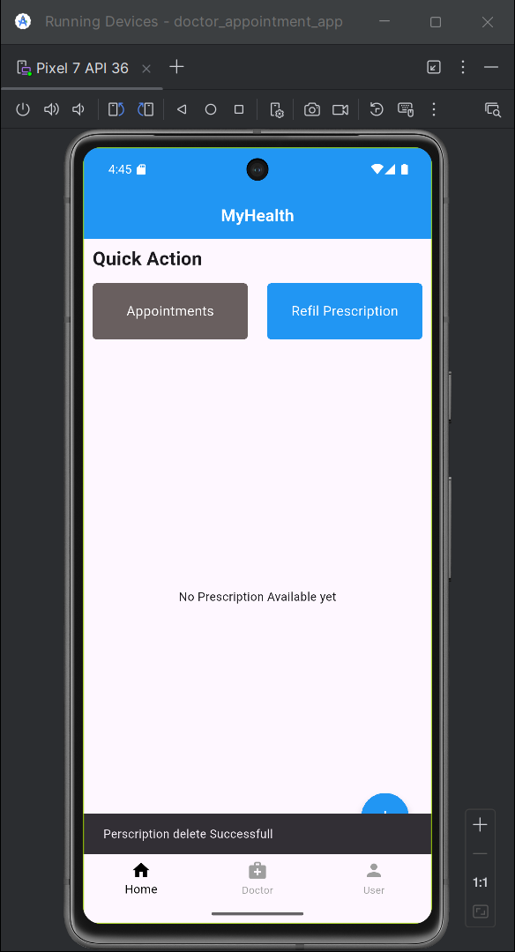

repository: https://github.com/AinaSaeed/appointment_app
Repository summary (observations)
- Repository: AinaSaeed/appointment_app
- Primary language: Dart (Flutter)
- Default branch: master
- Last pushed: 2025-11-10T19:43:50Z
- Visible top-level files & folders: .gitignore, .metadata, README.md, analysis_options.yaml, firebase.json, android/, ios/, lib/, linux/, macos/, test/, web/, windows/, pubspec.yaml, pubspec.lock
- Open issues reported in repository metadata: 0
- Data Storage (with Justification)
- Primary (recommended given repo clues): Cloud Firestore
  - Justification: real-time sync, offline persistence, scalable querying for appointments and users, first-class integration with Flutter and Firebase SDKs (firebase.json present suggests Firebase ecosystem).
- Secondary/Local: Hive or sqflite
  - Justification: fast local reads/writes for cached availability and queued offline bookings; Hive is simple to integrate and performant for key-value/structured objects.
- Audit & logs: append-only collection in Firestore or export to BigQuery for analytics.
- Alternate consideration: If strict relational integrity is required (e.g., complex joins across staff, resources), consider a small REST backend with PostgreSQL, but for typical appointment features Firestore is lower friction.
- State Management
- Viable options (choose one based on team familiarity):
  - Provider + ChangeNotifier (simple and idiomatic Flutter for small/medium apps)
  - Riverpod (safer, testable, and scales well)
  - BLoC / flutter_bloc (structured for larger apps with clear event/state separation)
- Recommendation: Riverpod for predictable DI, testability, and minimal boilerplate; use domain-specific providers: authProvider, bookingsProvider, availabilityProvider, settingsProvider.
- Keep UI components stateless where possible; isolate side-effects (network, local storage) in repositories/services.
- APIs / Packages / Plug-ins (inferred & recommended)
- Inferred from repo: Firebase integration (firebase.json).
- Recommended Flutter packages:
  - firebase_core, firebase_auth, cloud_firestore, firebase_messaging (if using Firebase)
  - provider / flutter_riverpod / flutter_bloc (state management)
  - intl (date/time formatting, localization)
  - table_calendar or syncfusion_flutter_calendar (calendar UI)
  - flutter_local_notifications (local reminders)
  - hive or sqflite (local persistence)
  - dio or http (HTTP client for external APIs)
  - url_launcher (open external calendar links)
  - flutter_localizations (i18n)
- Plugins for native features:
  - device_calendar or platform calendar integration (optional)
  - permission_handler (request calendar/notification permissions)
- For CI / linting:
  - analysis_options.yaml (already present) — enforce style, avoid anti-patterns.
- Issues and Bugs Encountered and Resolved
- Repository metadata indicates zero open issues. Specific historical issues are not visible here; common issues for Flutter appointment apps and how they are commonly resolved:
  - Timezone handling causing duplicated or shifted appointment times — resolve by storing times in UTC and presenting localized times via timezone-aware conversions.
  - Race conditions on booking (double booking) — resolve by using backend transactions or server-side checks (Firestore transaction or cloud function).
  - Push notifications not received on iOS — fix entitlements, APNs certificate/key, and ensure FCM iOS configuration is correct.
  - Calendar rendering performance on large datasets — fix by paginating events and using efficient list builders.
- Recommendation: add an Issues template and changelog to document bugs and resolutions.
- Maintainability and Coding Standards
- Evidence of static analysis: analysis_options.yaml present — good sign.
- Recommendations:
  - Adopt a consistent style guide (Dart style with effective dart rules).
  - Run static analysis in CI (flutter analyze).
  - Enforce formatting via dart format in pre-commit hooks.
  - Modularize code into feature folders (e.g., features/bookings, features/auth, core/services).
  - Add unit and widget tests for critical flows: booking flow, availability editing, auth flows.
  - Keep repository README up-to-date with setup steps (Firebase config, Google Services files), architecture diagram, and developer conventions.
  - Introduce semantic versioning and a CHANGELOG.md.
- Security and Privacy
- Observations & recommendations:
  - Store minimal PII in the database. When necessary, encrypt sensitive fields or use tokenization.
  - Use Firebase Security Rules (or server-side validation) to enforce access control: users must only read/write their appointments; providers get scoped access.
  - Protect API keys and service account credentials: do not commit google-services.json / GoogleService-Info.plist or private keys to the repository (use CI secrets / environment variables).
  - Use HTTPS and enforce TLS.
  - Implement authentication (email/phone/OAuth) with email verification and optional 2FA for sensitive accounts.
  - Comply with privacy regulations (GDPR/CCPA) if storing personal data: data export & deletion flows, privacy policy link in-app.
  - Add rate-limiting and record suspicious activity (failed login attempts).
  - For notifications, make sure to ask for permission and only send relevant data; avoid exposing private contents in notification payloads.
- Accessibility
- Recommendations to ensure inclusive UX:
  - Provide semantic labels for interactive widgets (semanticsLabel).
  - Ensure a logical focus order and keyboard navigation on web/desktop.
  - Maintain color contrast ratios; support large fonts and screen magnification.
  - Support screen readers (TalkBack, VoiceOver) by testing booking flows with them.
  - Avoid relying solely on color to convey information (e.g., use icons or patterns in addition to color).
  - Add localization support (flutter_localizations) and text direction if needed.
- Project Deliverables Mapping
- Minimum Viable Product (MVP) deliverables:
  - Cross-platform Flutter app with sign-up/sign-in
  - Provider availability management UI
  - Client booking flow with conflict checking
  - Appointment list and detail pages
  - Push/local notifications for reminders
  - Basic analytics: appointment counts, daily schedule
- Stretch / v2 deliverables:
  - Staff resource management and multi-provider scheduling
  - External calendar sync (Google/Apple)
  - Payment integration
  - Reports & exports (CSV/PDF)
  - Role-based access control for managers and staff
  - Admin dashboard (web)
- Developer deliverables:
  - README with setup & Firebase config steps
  - CI pipeline for building & testing
  - Tests (unit & integration)
  - Code style & contribution guidelines
- Conclusion This repository is a Flutter-based, multi-platform appointment app with evidence of Firebase usage (firebase.json) and standard Flutter project structure (android/, ios/, lib/, web/). The core problem it solves—streamlined appointment scheduling across devices—is well suited to a Flutter + Firebase architecture for rapid development and real-time sync.

